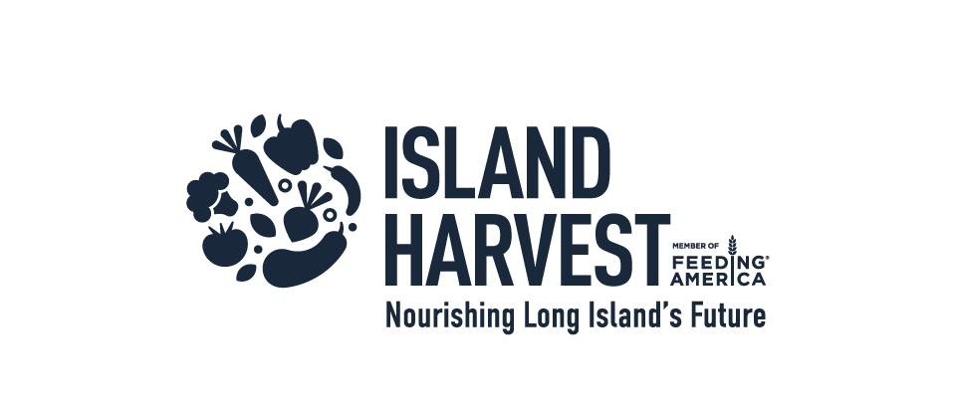 | September 2022
Sunday | Monday | Tuesday | Wednesday | Thursday | Friday | Saturday
 |  |  |  | 1 | 2 | 3
 |  | Orange is the color of hunger relief. During Hunger Action Month, we join together by wearing orange & raising our voices across LI on behalf of our neighbors facing hunger. |  | Follow our Hunger Action Month activities on social media @IslandHarvest & share this calendar with your friends.  Daniel Gale Warehouse Event | “Build A Box” This Month!  Get your Hunger Action Month box ready! Add 2 boxes of pasta.  PSEGLI Food Collection Event | Encourage your friends to get involved in the “Build A Box” challenge.  Broadway Commons Food Collection Event
4 | 5 | 6 | 7 | 8 | 9 | 10
Share your story on social media about how hunger has affected you. | Labor Day!  Have your friends bring extra canned goods to your BBQ to donate. | Box it up! Add 2 cans of vegetables to your Hunger Action Month “Build A Box” | See if your employer will make contributions to Island Harvest in honor of Hunger Action Month. | Box it up!  Add 2 plant proteins to your “Build A Box” (beans, peanut butter, etc.) | Contribute to support Island Harvest Food Bank.  https://bit.ly/3SSDhFX | Cook dinner and set an empty place to remind your family about others facing hunger & talk about it. Share a pic and tag us! @IslandHarvest
11 | 12 | 13 | 14 | 15 | 16 | 17
Sign up to volunteer at Island Harvest Food Bank.  https://bit.ly/3ADfOBz | Organize a dress down day in your office. Everyone contributes $5 to participate. https://bit.ly/3AFQgU8 |  | Write what you can do to end hunger on a paper plate and take a selfie. @IslandHarvest | Box it up!  Add 2 cans of fruit to your “Build A Box” | PSEG Food Collection Event | Share a fact about hunger on social media. @IslandHarvest  Pintail Coffee Event
18 | 19 | 20 | 21 | 22 | 23 | 24
Skip buying coffee for the week and contribute your savings to Island Harvest. https://bit.ly/3AFQgU8 | Organize a brown bag lunch with co-workers and contribute your lunch money. https://bit.ly/3AFQgU8 | Box it up!  Add 2 items of your choice to your Hunger Action Month “Build A Box” | Connect with us while shopping and choose us as your charity of choice under Amazon Smile. | Tomorrow is Hunger Action Day | Hunger Action Day– a day where collective efforts are focused to inspire people to come together to end hunger & raise awareness of people experiencing food insecurity across Long Island and the U.S. | Sign up Saturday!  Register to host your own food drive.  https://bit.ly/3c3hwTc
25 | 26 | 27 | 28 | 29 | 30
Box it up!  Add two cans of meat to your “Build A Box” | Can you live on $4.50 a day? Take the SNAP challenge and eat on $4.50 today. |  | Box it up!  Add 2 condiments to your Hunger Action Month “Build A Box” | Pick up extra items at the grocery store and add them to your “Build A Box.” | Deliver your “Build A Box” to Island Harvest Food Bank.

